Internet Applications – CP50078E – LAB 6

Exercise 1

- Open phpMyAdmin

- Create the following tables: products and categories
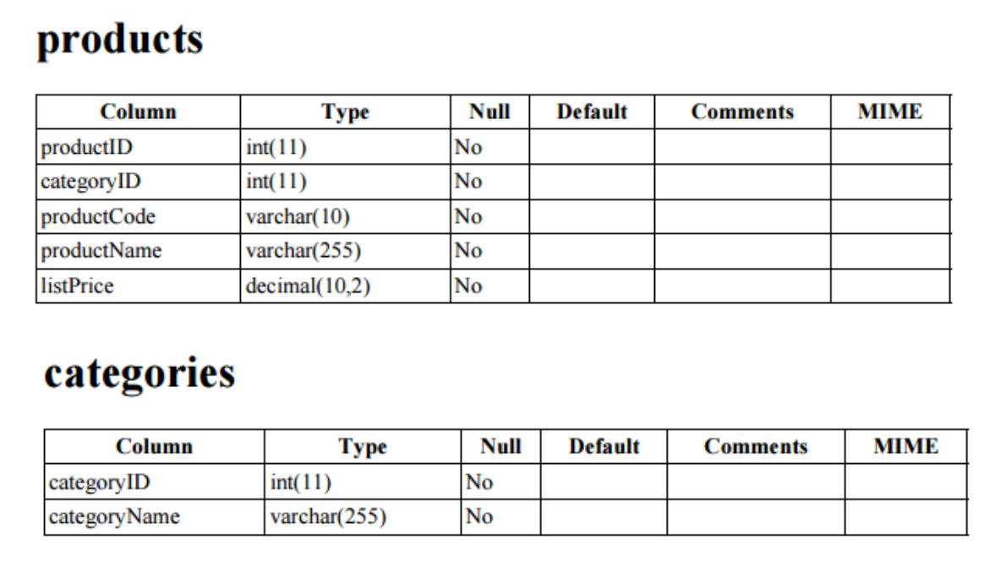

Insert the following data in categories table
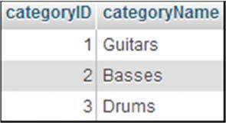

Insert the following data in products table
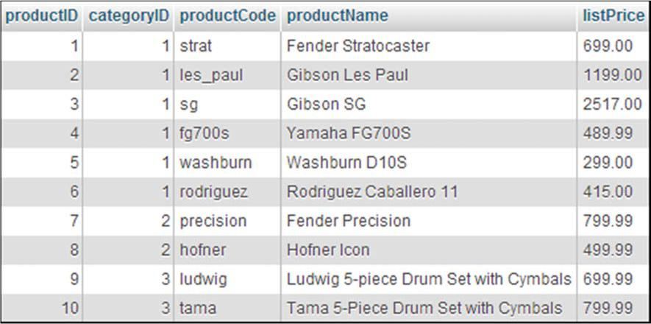

Exercise 2

3) Use the SQL tab to run the following queries:

SELECT * FROM products

WHERE categoryID = 2

a) Second query:

SELECT productName, listPrice FROM products

WHERE listPrice < 500 ORDER BY listPrice ASC

b) Third query:

INSERT INTO products

(categoryID, productCode, productName, listPrice)
VALUES
(1, 'tele', 'Fender Telecaster', 599.00)

c) Forth query:

DELETE FROM products WHERE productID = 1

d) Fifth query:

SELECT categoryName, productName, listPrice FROM categories
INNER JOIN products

ON categories.categoryID = products.categoryID WHERE listPrice > 800

ORDER BY listPrice ASC

- Repeat the experiments with more statements until you are confident that you know how to code the SQL queries that your PHP applications will use.

Note. You could use the examples from the lecture or the textbook.

